John Carroll

902521946/jcc0044

COMP 3700 – HW4

1)

**Concept Statement:**

The main library class holds the name of the library and keeps track of the customers, addresses, books, accounts, authors, and the reports, as well as the numbers for all of these items. The library also holds a reference to the librarian over the library. The librarian is able to add, delete, and modify all of the items inside of the library and can renew books for customers.

The library stores a list of users that keeps track of the user’s name, phone, and address. The address stores the street, city, state, and zip. Users are associated with accounts that keep track of their personal reports. The account also has a unique id, the date of creation, a status indicating whether it is open, suspended, or closed, and other stats such as how many books are issued to the account, the number of late and lost books. The account is able to check in and check out books as well as reserve books, pay fines, and view the personal status of the customer holding the account. The account holder can also create a reservation for a book that is currently checked out. At that point they will be placed in a reservation queue until the book is returned where the first to enter the queue will receive priority for checking out the book.

The reports store all the information of the transactions performed by the customers through their accounts. Each report has a unique id, a creation date, a due date, the status of the report and whether the book was checked in late or lost. This information is later used to compute the statistics for the account.

Their individual ISBN identifies the books stored in the library. They also store the title the number of pages, the genre, and a brief overview for the book. The library also holds a list of authors that describes the name of the author, his birth date, and a brief bio describing the author.

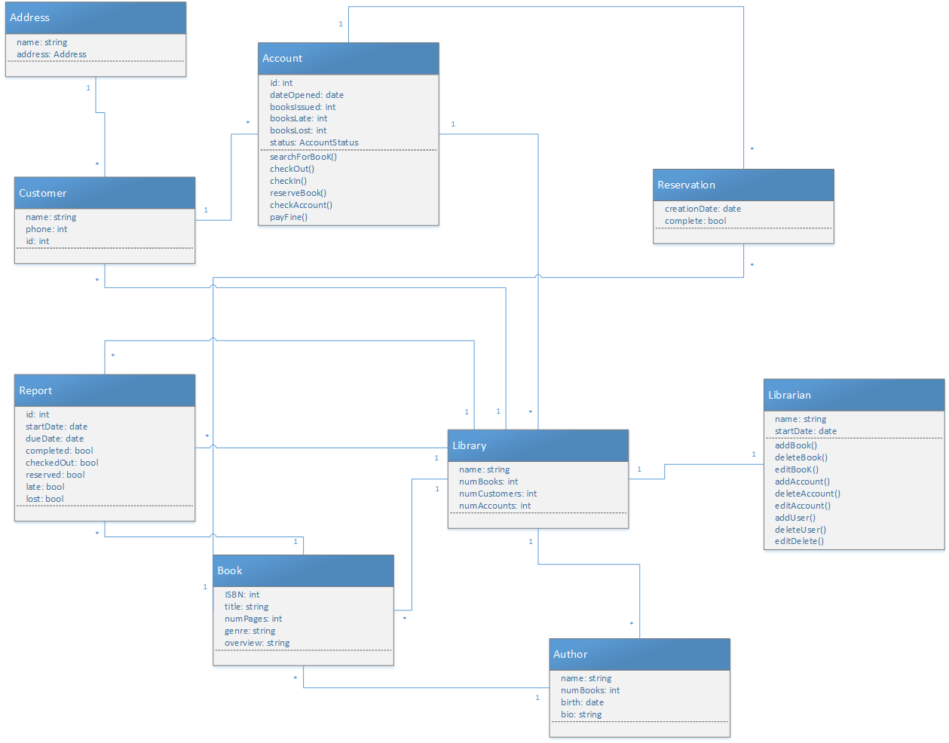

2)

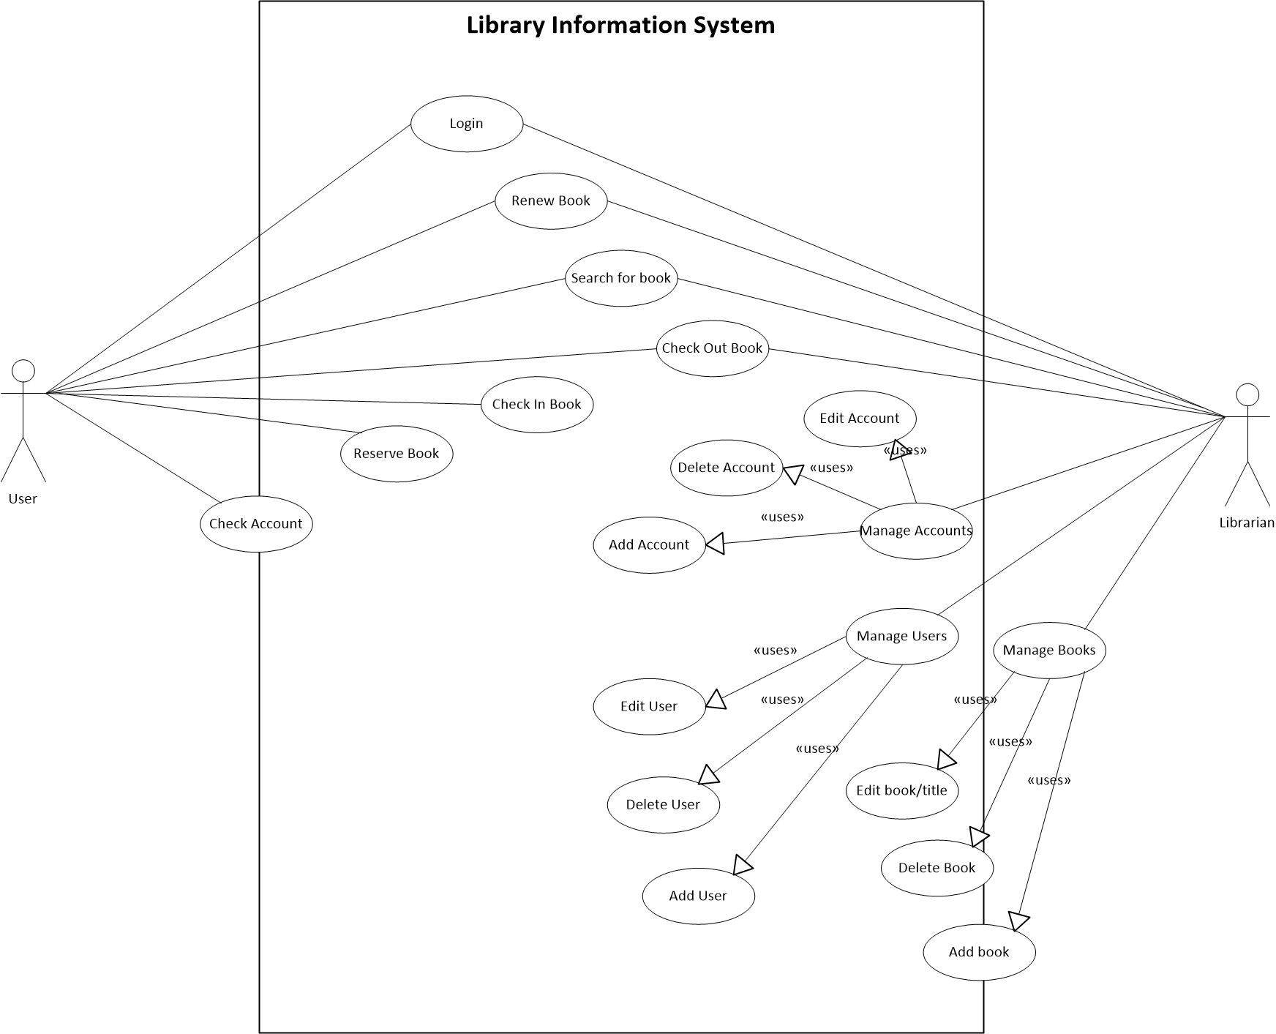

3)

|  |  |
| --- | --- |
| User | Librarian |
| User logs in  Searches for book to check out  Requests to check out book  User receives book  User logs out | Receives request for check out  Checks if account is eligible to check out book  If yes then check if the book is checked in  If yes checks if there are any pending reservations  If no then the book is marked as checked out  The librarian gives the book to user |

4)

**Scenario 1:**

User logs in, chooses a book and attempts to check it out. The librarian determines that the user’s account is suspended due to fines from a previous late book. The user's checkout request is denied and the user is notified of their fines and the declination.

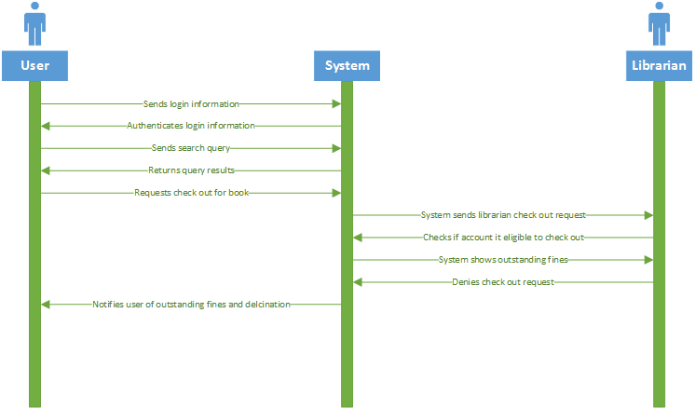

**Scenario 2:**

The user logs in, chooses a book and attempts to check it out. The librarian determines that the book is already checked out. The librarian notifies the user and prompts the user whether they want to reserve the book or not.

